Name | SYED AHMED SHAKHADRI
Class | 7 A1

Purpose:
"Skill Assessment Program - Building Strengths Beyond Academics "
This report shows your child's interests and abilities in different school activities. With your (parents) support and our guidance, these strengths can grow into useful life skills. It helps parents notice early signs of talent and areas where extra care or practice can make a big difference.

Key Insights:
The graph below shows how your child is doing in different areas. It tells us what they like more and where we can help them do even better. Blue represents your child, and red represents the class average.
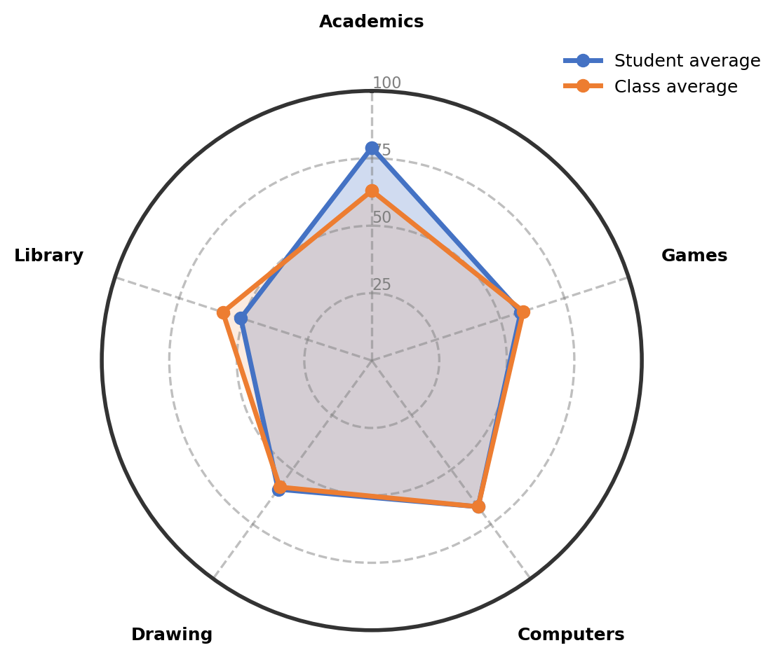

Observations:
The table gives an overview of child's involvement and performance across co-curricular areas.
Interest Area | Engagement (%) | Interest Level | Key Observations
Academics | 79% | Growing Strength in This Area | Shows clear interest in Urdu, Mathematics, and English subjects. The growing strength indicates consistent effort and engagement with these academic areas.
Computers | 67% | Showing Strong Interest | Demonstrates strong interest in computer activities, particularly typing. Shows good performance when motivated and engaged, though needs consistent practice to improve skills.
Drawing | 59% | Progressing With Guidance | Participates in drawing activities and shows willingness to learn. Needs guidance to follow measurements and maintain consistent participation in class activities.
Games | 58% | Progressing With Guidance | Enjoys playing cricket and shuttle games. Shows good participation in shuttle activities and has specific interest in cricket, though sometimes plays without clear objectives.
Library | 51% | Building Confidence Gradually | Enjoys story books and shows interest in reading. Sometimes finds difficult words challenging and needs support to maintain attention during library sessions.

Recommendations & Growth Opportunities:
Here are some ways to turn your child's interests into long-term strengths:
Strong Interest Area | Potential Careers | Simple Activities to Support
Computers  (67%) | This strong interest in computers can lead to various technology-related career fields. Exploring software development, data analysis, digital content creation, or IT support is possible. Developing computer skills now builds a strong foundation for many future opportunities. | Enroll in a structured computer typing course or coding workshop for beginners to build keyboard skills and logical thinking
Games  (58%) | This interest in sports and games can connect to various physical activity and teamwork fields. Exploring sports coaching, physical education, recreation management, or fitness training is possible. Developing coordination and teamwork skills through sports benefits many aspects of learning. | Join a local cricket coaching program or shuttle badminton classes to develop specific sports skills and techniques

How Parents Can Help:
1. Weekend Exploration (Computers): Dedicate a weekend afternoon to a fun, structured online typing tutorial or simple coding game that builds keyboard skills and logical thinking, connecting to the interest in computers.
2. Short Daily Practice (Games): Encourage 15 minutes of focused cricket or shuttle practice in the evening with specific goals like improving a particular shot or serve to develop sports skills.
3. Encourage and Talk: Dedicate 10-15 minutes weekly to talk about what excites your child in their computer and sports activities and offer appreciation for their efforts and progress.

Conclusion:
Your child shows wonderful natural interests in both technology and physical activities. The growing strength in academics and clear engagement in computers and games indicates healthy exploration at this stage. Remember that middle school is about discovering interests and building skills gradually. Each small step in computers, sports, and academics contributes to well-rounded development. Continue supporting these interests with patience and encouragement as natural strengths continue to emerge.

Notes:
Parents remarks:
Teachers' remarks:

